**Congratulations to the 2023 Scholarship Winners!**

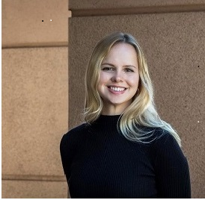

**Jadyn Anderson awarded $4,000**

Jadyn Anderson is from Luverne, Minnesota. Her step-father is an employee of the Buffalo Ridge Insurance Agency located in Luverne, MN. Jadyn is pursuing a Masters in Architecture from the University of Wisconsin in Milwaukee.

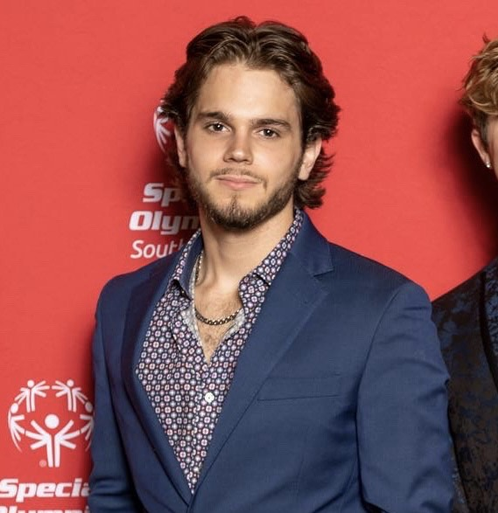

**Seth Scholl awarded $3,000**

Seth Scholl is the son of MFM employee, Michael Scholl, located in Blythewood, South Carolina. Seth is attending the University of South Carolina/Beaufort in Bluffton, South Carolina. Seth will study Psychology with the goal of working towards his Master’s degree after graduation.



**Samantha Zuel awarded $3,000**

Samantha Zuel is the daughter of MFM employee, Christie Fuller, located in Chariton, Iowa. Samantha will be attending Indian Hills Community College in Ottumwa, Iowa. She will study Music and Fine Arts.

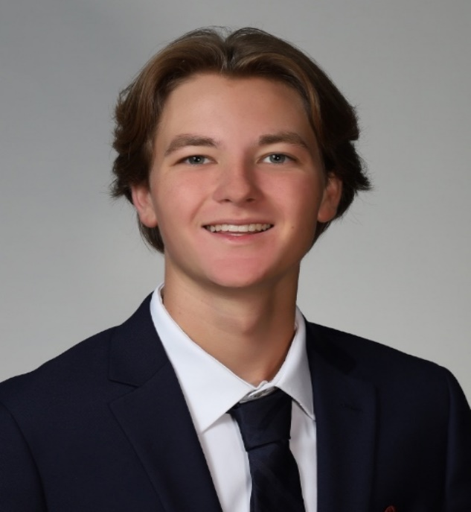

**Logan Rhodes awarded $3,000**

Logan Rhodes is the son of MFM employee, Kristin Rhodes, located in Overland Park, Kansas. Logan is attending the University of Kansas, and expects to graduate in 2025 with a degree in Exercise Science. Following graduation, Logan plans to go to Medical School.

r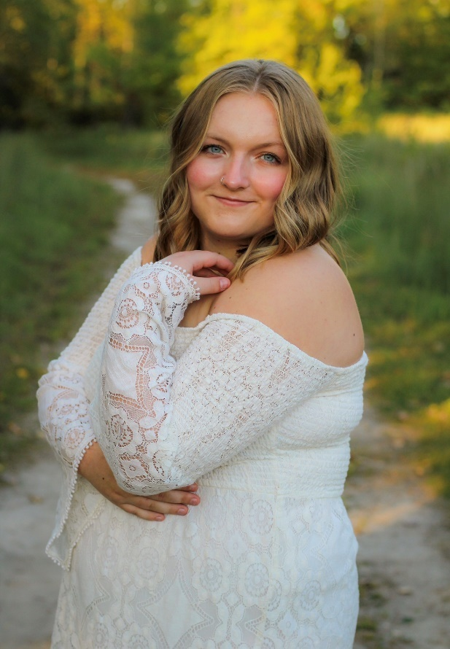

**Kaitlyn Culbert awarded $1,000**

Kaitlyn Culbert is from Minnesota Lake, MN. She will be attending Minnesota State University in Mankato, majoring in Elementary Education. Kaitlyn is the granddaughter of MFM employee, Pam Culbert, from Paynesville, MN.

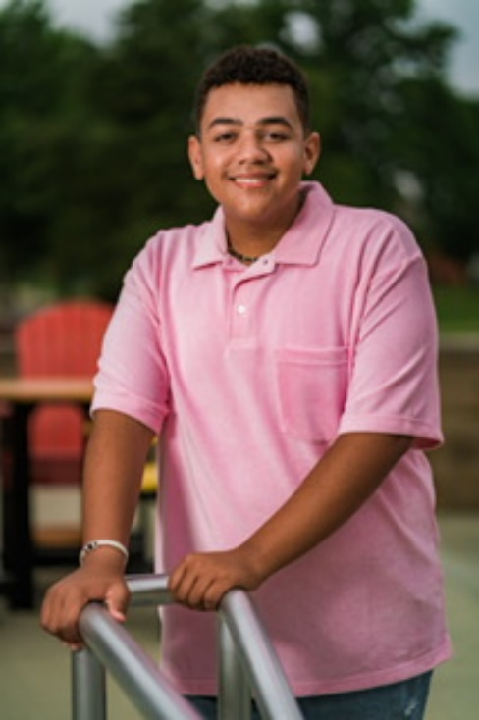

**Jaxon Hunt awarded $1,000**

Jaxon Hunt is the son of an MFM Agent from Burkhart Insurance. Jaxon is from Vincennes, Indiana. He will major in Public Relations at the University of Southern Indiana, located in Evansville, Indiana.