Congratulations……2021 Scholarship Winners renewed for 2023-2024!

Lois Lancaster Scholarship Renewal
Lois is from Parma, Ohio. Lois applied in 2021 through MFM’s Agent, David Lancaster, located in North Royalton, Ohio. She is attending the University of Toledo to study Biological Chemistry.

Isabelle Salters Scholarship Renewal
Isabelle lives in Valentine, Nebraska. In 2021, she applied through MFM’s Agent, Sandhills Insurance Agency, located in Valentine, Nebraska. Isabelle is attending Concordia University to study Business Administration and Marketing.

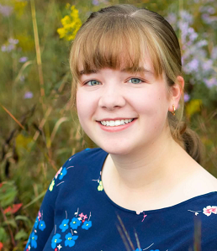
Anika Nordin Scholarship Renewal
Anika lives in Mahtomedi, Minnesota. In 2021, she applied for a scholarship through MFM’s Agent, Christensen Group. Anika attends the University of Wisconsin River Falls. She is studying Elementary Education with the goal of becoming a teacher.

Jessica Schonhoff Scholarship Renewal
Jessica lives in Argusville, North Dakota. In 2021, she applied for a scholarship through MFM’s Agent, First International Insurance, located in Fargo, North Dakota. She is attending the University of Minnesota – Twin Cities.

