Congratulations….. scholarships renewed for 2022-2023!
Mallory Kramer scholarship renewal $2,000
Mallory is from Blue Mounds, Wisconsin, and applied, in 2021, through MFM’s Haussman Johnson, MFM Agency in Madison, WI. Mallory is attending MATC in Madison, WI.
Lois Lancaster scholarship renewal $1,200
Lois is from Parma, Ohio. Lois applied in 2021 through MFM’s Agent, David Lancaster, located in North Royalton, Ohio. She is attending the University of Toledo to study Biological Chemistry.

Isabelle Salters scholarship renewal $1,200
Isabelle lives in Valentine, Nebraska. In 2021, she applied through MFM’s Agent, Sandhills Insurance Agency, located in Valentine, Nebraska. Isabelle is attending Concordia University to study Business Administration and Marketing.

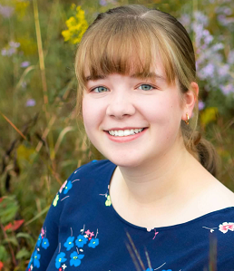
Anika Nordin scholarship renewal $1,200
Anika lives in Mahtomedi, Minnesota. In 2021, she applied for a scholarship through MFM’s Agent, Christensen Group. Anika attends the University of Wisconsin River Falls. She is studying Elementary Education with the goal of becoming a teacher.

Jessica Schonhoff awarded $1,200
Jessica lives in Argusville, North Dakota. In 2021, she applied for a scholarship through MFM’s Agent, First International Insurance, located in Fargo, North Dakota. She is attending the University of Minnesota – Twin Cities.

