Congratulations to the 2021 Scholarship Winners!
Mallory Kramer awarded $2,000
Mallory is from Blue Mounds, Wisconsin, and applied through MFM’s Haussman Johnson Agency located in Madison, Wisconsin. Mallory will be attending Southwest Technical College in Fennimore, Wisconsin, to obtain an Associate’s Degree in Nursing.
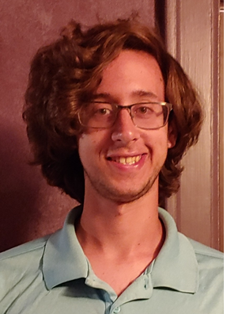
Nicholas Walecka awarded $2,000
Nicholas is from Sheboygan, Wisconsin, and is the son of Mark Walecka, a MFM employee. He will be attending the University of Wisconsin Green Bay to study Democracy and Justice with the goal of being a police officer.

Lois Lancaster awarded $1,200
Lois is from Parma, Ohio. She applied through MFM’s Agent, David Lancaster, located in North Royalton, Ohio. She will be attending the University of Toledo to study Biological Chemistry.

Isabelle Salters awarded $1,200
Isabelle lives in Valentine, Nebraska. She applied through MFM’s Agent, Sandhills Insurance Agency, located in Valentine, Nebraska. Isabelle will be attending Concordia University to study Business Administration and Marketing.

Anika Nordin awarded $1,200
Anika lives in Mahtomedi, Minnesota. She applied for a scholarship through MFM’s Agent, Christensen Group. Anika attends the University of Wisconsin River Falls. She is currently studying Elementary Education with the goal of becoming a teacher.

Jessica Schonhoff awarded $1,200
Jessica lives in Argusville, North Dakota. She applied for a scholarship through MFM’s Agent, First International Insurance, located in Fargo, North Dakota. She will be attending the University of Minnesota – Twin Cities.

